Shabbos Stories for
Chanukah festival 5778
Volume 9, Issue ??? 25 Kislev 5778/ December 13-20, 2017
Printed L’illuy nishmas Nechama bas R’ Noach, a”h

For a free subscription, please forward your request to keren18@juno.com

Story #995
A Deserved
Chanukah Miracle
From the desk of Yerachmiel Tilles
editor@ascentofsafed.com

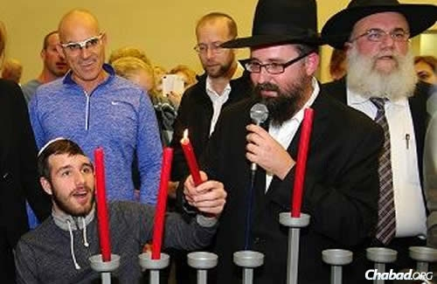

The first time Rabbi Menachem Kutner and Rabbi Yossi Swerdlov of the Chabad Terror Victims Project met Sgt. Ohad Benyishai of the Israel Defense Forces, he was lying unconscious in a hospital bed. He had been critically injured in mid-July of 2014 during "Operation Protective Edge" in Gaza, where he was deployed with his Golani Brigade's elite Egoz commando unit.
He and his unit's comrades were involved in a brutal battle in Gaza's Shuja'iyya neighborhood, which later became known as the bloodiest battle with Hamas during the entire operation. Thirteen soldiers lost their lives during the battle and many were injured. Ohad suffered a serious shrapnel wound of his head and was identified as the most seriously injured soldier during the operation.
He was quickly airlifted to the Soroka Medical Center, where on his arrival, his condition was so serious that the hospital doctors did not think he would make it through the night, but they refused to give up. After an unrelenting battle to stabilize Ohad that lasted a few weeks, Ohad rewarded their efforts when he regained consciousness.
In the months that followed, Benyishai slowly, with great determination and effort, and with devoted family support, began relearning how to function. He also mastered the Hebrew alphabet, and had even managed to say two words, ima (mom) and abba (dad), but no more.
On the second night of Chanukah, the rabbis visited the Sheba Medical Center in Ramat Gan, where he was recovering and had just celebrated his 20th birthday. There, around 70 wounded soldiers, their families and Chabad volunteers gathered for a special celebration and menorah-lighting.
Benyishai was invited to light the menorah together with Kutner. The rabbi said the blessings, and Benyishai held the shamash (helper candle) with his functional left hand. With the rabbi's assistance, he lit the two candles.
Then suddenly, the room went quiet as Benyishai slowly began to mouth the words to "Haneirot Halalu" and "Maoz Tzur" along with Kutner. The familiar traditional Chanukah tunes that he had learned during his childhood had brought back his ability to speak. He was talking!
His parents ran to him, and showered him with hugs and kisses with tears streaming down their cheeks. They had their Chanukah miracle.
Ohad was released from Sheba Hospital after an 18-month long recovery period on Monday, February 8, 2016, and returned home, but he will need to continue to undergo rehabilitation procedures in order to regain his full capacity.
Please continue to pray for the ongoing recovery of Ohad ben Erica, and the brave men and women of the IDF who have sacrificed so much to protect our precious homeland.
Source: Adapted and supplemented by Yerachmiel Tilles from an article on //Chabad.org. (The 2nd paragraph is adapted from //IsraelToday.co.il; the 2nd-to-last paragraph is from //IsraelNationalNews.com (Arutz Sheva). The photo is also from Chabad.org.)
Connection: Seasonal: Chanukah miracle.

Reprinted from the December 26, 2016 email of KabbalaOnline.org, a project of Ascent of Safed. www.ascentofsafed.com ascent@ascentofsafed.com

Chanukah: If You're Assimilated, It's a
Season of Confusion
By Miriam Karp/AMI

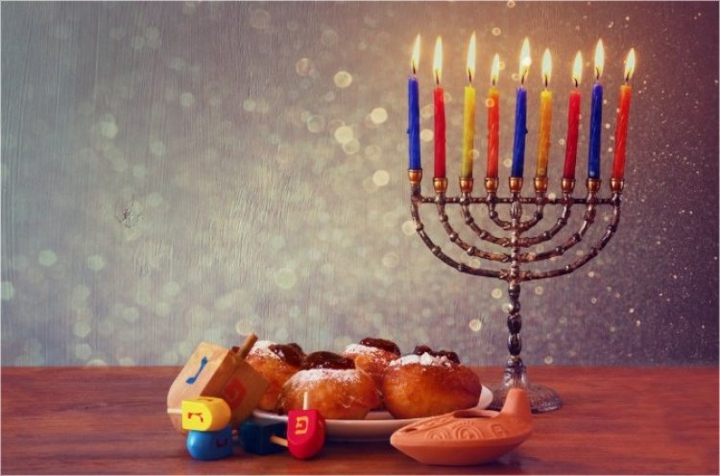

December is the season of utter confusion for a Jewish kid from an assimilated family wading through the American melting pot. Unless you have a very clear, strong Jewish identity, you feel the tension. What do you answer the cashier who extends a certain holiday greeting? What about the school play and the company party? It’s the time of year for clarification.
As the month progresses, the mall parking lots fill up, and the green and red decorations become ubiquitous, the unaffiliated Jew is pushed to reexamine and redefine the “Jewish thing.” Where does he draw the line and assert his differentness? Such questions are usually lost in the anesthetizing din of the media and the pressures of daily life. But come December, they’re hard to ignore. Growing up in the suburbs during the 1960s, I was torn. A second-generation American, my childhood was saturated with Yiddish culture, Bubby’s knishes, Jewish jokes and Fiddler on the Roof, but little in the way of real Jewish beliefs or day-to-day practice. I was jealous of my non-Jewish friends’ tree, candy canes and mountains of presents. I wanted to fit in. Badly.
Our little menorah and greasy latkes couldn’t compete with all that glitz. So I did sit on you-know -who’s lap, especially since our family friend Rube Weiss was the most famous one in town. I begged my parents for a Chanukah bush, but they weren’t willing to go that far.
Then one year Grandma Ida said yes! Grandma had been raised in an Orthodox home. On her wall, her parents looked out sternly from a turn-of-the-century photo, her father clad in a long black coat and hat, her mother peering out from under a boxy sheitel. Unfortunately, uneducated in Jewish matters and married to a socialist, Grandma kept her superstitions to herself.
We modern, rational Jews had no need for “kenahoras” and all that nonsense. Keeping kosher was a quaint relic of ancient times; nowadays we had sanitation and refrigeration. Grandma Ida sighed and accepted the new order. She smiled and bought us a Chanukah bush and stockings for the fireplace, and in the spring she bought us marshmallow bunnies and chocolate chick baskets. Why should her grandchildren be deprived?
I wish I’d learned something authentically Jewish from someone who was knowledgeable when I was young and far adrift. Maybe it would have saved me from roaming so many dead-end streets in my search for something deeper. Baruch Hashem, after light-years of searching, intensive change and discovery, I knew exactly what to do in December: get out that menorah, start frying latkes, invite the neighbors—the works.
Chanukah was celebrated with all of its genuine warmth, light and holiness; the kids were suffused with joy and excitement. I knew they were in quite a different place than I had been at their age when we happened to drive past a display of lights one year.
“Close your eyes!” my son Mendy, the little zealot, yelled to his siblings. “It’s avodah zarah!”Indeed, December is the season of sadness and confusion for so many well-meaning Jews. For several years I taught in a Reform Hebrew school. I was able to make my own curriculum and viewed the job as outreach.
Every year before Chanukah we’d have a discussion about what we were doing for the holidays. It was usually the smartest, most Jewish-looking kid in the class who would inevitably tell me, “We’re spending Chanukah with one grandmother and the other holiday with the other grandmother.”
“Oh,” I’d say with a sinking heart. “Which grandparents are Jewish?” David Cohen or Sarah Friedman or Josh Rubinstein, another nice kid, would invariably reply, “My dad’s parents.”
We are taught that only a small fraction of the Jews who were enslaved went out of Mitzrayim. I am often amazed and bewildered; how on earth did I start out way over there, wondering why my parents kept making that ridiculous racist demand that I marry a Jew—and end up all the way over here? How did I manage to jump over that vast cultural divide?
I don’t know; it must be zechus avos. How did I give up my university-conditioned cynicism? How did I accept covering my hair, so much cooking, cleaning for Pesach, kapparos—all the myriad details?
As I look back over my shoulder at those who are still on that distant multicultural shore, I realize how difficult it is for them to relate to all the stuff we do over here. They don’t even have the language to ask the right questions, to know how hungry they are.
Finding a way to show them how beautiful it is seems daunting. Some people might say, “It’s over. You can’t worry about them. Don’t look back; just hang on tight and build new generations. It’s sad, but that’s how it is. They’re gone.”
I don’t like that. It hurts. It’s wrong. I know how sweet and good those confused, earnest, assimilated and seemingly lost neshamos really are. I’d much rather sing “No Jew Will Be Left Behind” with Avraham Fried. But such a vision seems impossible. My father recently met his best friend from kindergarten, a friendship that has lasted over 80 years.
This dear man and his wife just moved into a non-Jewish assisted-living facility, complete with poinsettias and figurines and all of the other December trappings. Having long ago made peace with his intermarried sons and non-Jewish daughters-in-law and grandchildren, he is no longer bothered by the lack of kosher food or other Jewish staples. My heart aches thinking of them spending their twilight years in such a place.
Bridging the gap seems impossible. Like Chanukah. Like Eretz Yisrael. Like the Jewish people. How does such a ragtag band of persecuted wanderers continue to exist? How did the few beat the many? How did one tiny cruse of oil last eight days? How did I make that transition to the world of Torah, becoming the matriarch of a tribe of children and grandchildren with proud Jewish names and identities, bli ayin hara, whose lichtige pictures grace my dining room wall? Visitors gaze. It’s not an earthly thing. It’s not even logical to have raised all those kids, paid tuition, and bought shmurah matzah on a chinuch salary. It doesn’t make any sense at all. It’s a heavenly thing, like Chanukah, like the pintele Yid, the pilot light of the soul that continues to burn in even the most distant, most assimilated Jew.
Nowadays I travel a lot to speaking engagements. Invariably, in every audience, she is there—the one I was meant to meet. We recognize each other. A psychiatrist. An artist. A mom. A grandma. These neshamelach come in many forms and span the spectrum of socioeconomic and educational back grounds.
All their status and busyness just didn’t satisfy them. They’re all hungry neshamos, alive, the flame reaching upward, almost jumping off the wick with excitement. They’ve finally found a name for the driving force that’s been making them crazy all these years. They’ve found out where to get their neshamos some wholesome food.
I’m usually more inspired than they are. I’m revived. It’s really true—the Jewish neshamah cannot be extinguished. Each one has its own journey, its moment, when the dormant cinders blaze anew. And Hashem will lead each one lovingly home. Each one.
Take that, Pew Report, with your grim statistics! Where do we light the menorah? In the window, in the doorway. We’ve got to let that delicious light shine out into the darkness, burning until each soul is brought in from a cold, dark, empty street.
Inside. Around a warm table. And our light— Hashem’s light—is enough, enough to outshine the tinsel and the thousand million shtussim (foolish things) out there. And though it’s sometimes hard to see just how it will happen, it’s enough to bring them all home.

Reprinted from the Chanukah website of Hidabroot.

L’Maaseh

The Broken Flask

Rav Shabsi Yudelevitz, zt”l, one of the famous Magiddim of Yerushalayim, relates a beautiful and inspirational story. A poor Rabbi, who over a hundred years ago, had to go to Milan, Italy, to collect money for his family. When he got off the boat he met a wealthy, Jewish man, and he invited the Rabbi to spend Shabbos with him.
At the Seudah that night in the wealthy man’s mansion, the Rabbi saw a beautiful closet filled with exquisite silverware and crystal. He also saw something that seemed to be out of place amongst the luxurious items— a broken glass flask, with sharp points of jagged glass jutting out.
The wealthy man noticed the Rabbi’s look and asked him if everything was all right.
The Rabbi asked about the broken flask, and the wealthy man was more than happy to tell him the story.
The man was born in Amsterdam and came to Italy when he was eighteen years old, to help his grandfather run the family business. Eventually, his grandfather passed away, and his parents wanted him to sell the business and return to Amsterdam. The man, however, was very successful in the business and decided to remain in Italy, where the business kept him very busy.
One day, he was so involved with work that he forgot to Daven Minchah. A few days later he got busy early in the morning and he realized that he had forgotten to Daven Shacharis, and one by one, he stopped doing Mitzvos. Eventually he got married and had children, but he was leading a secular life. He remembered that he was Jewish, but he barely practiced any of the Mitzvos.
One afternoon he was taking a walk and saw some children playing. They all seemed to be very happy, but then he heard one of them start screaming and crying, and he kept saying, “What will I tell my father? What will I tell my father?” No one could console him.
The wealthy man went to see what the problem was. He found out that the boy came from a poor family and that his father had saved a few precious coins throughout the winter to buy a flask of oil for Chanukah, and sent this boy to buy it. His father warned him to come straight home with it and not to stop and play with his friends, as the flask may break. The boy didn’t listen, though, and sure enough, while he was playing, the flask broke and the oil spilled out.
The man asked the boy to come back to the store with him, and he would buy new oil for him to bring home. The man bought a larger flask of oil than the boy had originally gotten, and sent the now happy boy straight home with the precious oil, as well as some money for his family.
As the wealthy man was walking home that evening, the little boy’s words rang in his ears. “What will I tell my father? What will I tell my father?” And then he thought to himself, indeed, what will I tell my Father? My Father in Shamayim, Hashem, after my time here on this world? He had drifted so far from Yiddishkeit that he had forgotten that is was almost the first night of Chanukah! What excuse would he have when he stood before his Father in Heaven on that final Judgement Day?
The man walked back to where the children were playing and picked up the broken pieces of glass from the flask and took it home with him. That night, to the surprise of his wife and children, he lit a Chanukah candle. The next night, he lit two, and with each passing night, he increased the amount of candles for eight nights. He stared at the candles as they flickered and sparkled, and he remembered his parent’s home back in Amsterdam. He had realized that he had gone too far away.
The wealthy man concluded his story, “That Chanukah was the beginning of my return to the observance of Mitzvos. Eventually, with the understanding and help of my wife, we began training our children the way we were brought up. Our road back had started with that broken flask and the words of that boy, ‘What will I tell my father?’ And that is why I keep the broken pieces of that flask, as a treasured reminder of what changed my life!”

Reprinted from the Chanukah 5777 email of Torah U’Tefilah: A Collection of Inspirational Thoughts compiled by Rabbi Yehuda Winzelberg.

Behind World's
Largest Menorah
By Moshe Ben Chaim

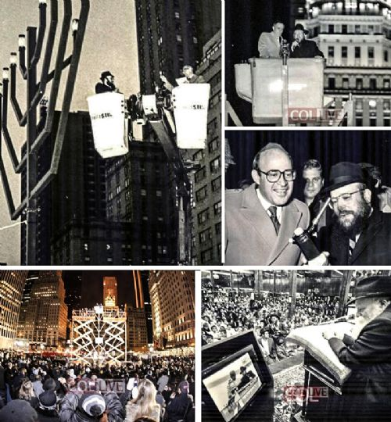
How did the world's largest Menorah end up on Fifth Avenue and how did Mayor Ed Koch shut down Chabad's critics.

As we store away our Menorahs until next Chanukah, we wanted to focus the emphasis on one of the most unique public lightings -- on Fifth Avenue in Manhattan.
There, as every year, proudly stands a gigantic Menorah, the largest in the world, according to Guinness World Records, that brings a phenomenal amount of publicizing of the miracle of Chanukah, as every day hundreds of thousands of people are exposed to it.
The Kfar Chabad magazine recently revealed interesting details about how this Menorah came about, in an interview with prominent officer of the Israel Defense Ministry and the Israel Foreign Ministry Yossi Ciechanover. His wife, Mrs. Atara Ciechanover, initiated the concept of this menorah.
The Chossid who took upon himself, at the time, the expenses of the Menorah and who actually organizes all the public lightings of the Menorah is Rabbi Shmuel Butman, the director of the Lubavitch Youth Organization.
It was difficult to reach Rabbi Butman during Chanukah as he was busy with daily arrangements for the public lighting with the participation of public figures and guests.
Now that Chanukah is over, we asked to speak to him and to hear about the "behind the scenes" story and it seems that many details were not yet revealed.

How did it all start?
In the 1970's the Rebbe spoke about public Chanukah Menorahs to publicize the Miracle of Chanukah. "We wanted to do that in the best way that befits the Big City," Rabbi Butman told us in the talks that we had with him this week.
"This is how in 5738 (1977) this Menorah was built. The size of the Menorah was 30 feet. We called the Menorah the "World's Largest Menorah" and that is how it was recorded by the world media who covered extensively the lightings each day. World media used the Menorah as the symbol of Chanukah."

Who designed the Menorah? Who built it? And what was the cost?
We used a classic design. It was not yet the custom to use the Rambam design. After considerable efforts we found, with G-d's help, a company who specialized in designing and building objects of metal and steel.
The company wanted $5000 for the design and construction. Not a small sum in those days. I contacted a supporter, Mr. William Goldberg OBM, president of the Diamond Dealers Association. Mr. Goldberg was so excited with the idea that he personally came to our office and paid for the Menorah.
Although he is no longer with us, his wife comes to the Menorah each year and feels like a partner.
For nine years, this Menorah captured the attention of the world media, due to the unprecedented Pirsumei Nisso publicizing of the miracle of Chanukah. Every year the media flocked to cover the Menorah. Even the New York Times, that isn't always enthusiastic about Jewish matters, wrote about this Menorah."

When was the famous Agam Menorah built?
In 5747, Yaacov Agam designed the Menorah. A model of the Menorah in miniature stood on the Rebbe's desk for 3 days. The entire project was arranged by Mrs. Ciechanover.
According to the words of Yaacov Agam, the Rebbe wanted the Menorah to be built to the maximum height permitted by halacha, 20 Cubits, which is 32 feet. The price for constructing this Menorah was $25,000, paid by the Lubavitch Youth Organization.

And what exactly did you do with the first Menorah?
That Menorah, till this day illuminates the surroundings at "Park Circle," the gateway to Crown Heights, Boro Park and Flatbush, where tens of thousands of vehicles pass by daily."

Which directives were from the Rebbe concerning this Menorah?
Rabbi Mordechai Hodakov, the head of the Mazkirus (secretariat) of the Rebbe showed an interest in all the details. Who is lighting today? etc. According to his directives we invited the then Mayor Abraham Beame to light.
I remember that Rabbi Hodakov very much wanted that United States Senator Jacob K. Javits should light the Menorah. Javits at the time was old and in poor health. It did not seem possible that he would come. But when Rabbi Hodakov said that he wants him to light, I went to work on it. With Rabbi Hodakov one never knew 'where the directive comes from.' Thank G-d it was with success. Senator Javits came, got into the lift and lit the Menorah.
I once got a call from Rabbi Yehuda Krinsky, the Rebbe's secretary. It was the night that the eighth candle was lit. The Rebbe told him that night to call me and ask me to light the Menorah again the next morning. We do this till this very day.

These directives came straight from the Rebbe?
This is part of what it says ‘to what is beyond you don't reach.' I will give you a case in point. Rabbi Hodakov told me to invite Robert Abrams to light. He was at the time Bronx Boro President. I answered that I don't know if there are enough open nights. Rabbi Chodakov just repeated what he said, that Robert Abrams should be invited. He was invited and he came.
A few years later Robert Abrams was elected as Attorney General of the State of New York. He came every year to light the Menorah. When an individual complained to the Rebbe about the separation of Church and State the Rebbe responded that how can there a problem of Church and State when the man in charge of that in the State of New York came himself to light the Menorah. One then understood that the suggestion of Rabbi Hodakov came ‘from above.'"

One cannot help but admire the spot that the Menorah was given...
Indeed. This is a case of S'yato Dishmayo, (heavenly intervention). Within the laws of nature, we had a good relationship with Mayor Abe Beame and he gave the order. The permit officially was issued by the Parks Department but the permission came from the Mayor's office."

Many stories have accompanied the Menorah. Can you share one of them with us?
Every New York Mayor lit the Menorah, including Ed Koch. Ed Koch was once invited to St. Louis as the Guest Speaker for the United Jewish Appeal. After his formal speech, a woman who was at the time the head of the opposition to the lightings of public Menorahs [in St. Louis], asked him for his opinion. She was certain that he would oppose it. Ed Koch answered in his characteristic blunt manner: "In my city, we have the largest Menorah - and I myself lit it." Supporters of the public lightings applauded at length and the Menorah [in St. Louis] went up.

In conclusion, Rabbi Butman, what is your message?
That the lights that all Jews and the Rebbe's Shluchim light, the world over, should usher in the eternal light of the great redemption imminently.

Reprinted from the January 5, 2017 website of COLLIVE.com
What You Should Know About “Sufganiot”
Jelly Doughnuts
By Leon Samuels

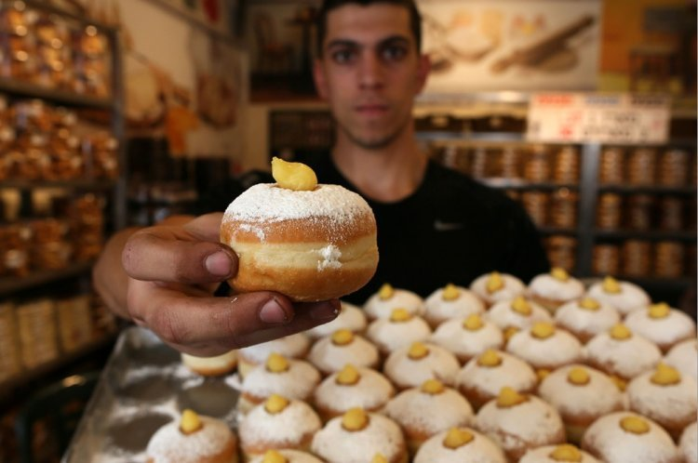

Why Kashrut Supervision is Important
When You Buy a Sufgania.

Chanukah is around the corner. One of the Chanukah customs is to eat foods fried in oil to remind us of the miracle of oil. Jelly doughnuts rate high on the Chanukah menu along with potato latkes. In Israel most of us already had a sneak preview tasting of the jelly doughnuts (which could be filled with caramel, custard or other fillings other than jelly).Rabbi Pinchas Adiria, Supervisor of the Kashrut Division of the Israel Rabbinate, want people to know what to look in Kashrut for when buying these doughnuts. This first part is general advice but more applicable to Kashrut supervisors or those making the doughnuts at home.
1) Make sure the deep fryers were kashered making sure they are not meaty and have not absorbed non-kosher substances.
2) A Jew must turn on or light up the deep fryers.
3) If the dough is large, 2 kg. or more of flour, Challah must be separated before using dough.
4) Make sure flour was properly sifted to remove small bugs common in flour.
5) When using a dairy filling like caramel some filling should be obviously visible on top so people will know it is dairy and not accidently eat it with a meaty meal. A merchant must place a “dairy” sign next to these doughnuts.
6) Merchants must have separate areas for dairy doughnuts and parave doughnuts. They should also refrain from making dairy dough so as not to get confused and make a parave doughnut with this dough.
7) Packaged doughnuts should be appropriately labeled “Parave” or “Dairy”.
For doughnut buyers:
Make sure the bakery has proper kashrut supervision from the local Rabbinical Council. This prevents kashrut fraud. Because of all the aforementioned requirements proper Rabbinical supervision is imperative.
Enjoy your kosher jelly doughnuts and have a great Chanukah!

Reprinted from the December 20, 2016 website of Hidabroot.
Chanukah at Valley Forge, 1777
From the desk of Yerachmiel Tilles

It was December 1777, when the American forces under General George Washington were awaiting the famous battle at Valley Forge. The future president was deeply concerned about the welfare of his troops. The bitter cold and the poor provisions with which his soldiers of the revolutionary army had been provided did not bode well for the outcome of the critical battle that awaited them.
Wrapped in his officer's cape and clapping his three-cornered hat down hard on his head against the chilling wind, Washington went out to see at firsthand how his men were faring. As he went from tent to tent, he saw the men dressed in rags and huddling around small fires, trying to get together a meal of something hot. As he went on, he suddenly encountered a single soldier, bent over a small metal apparatus in which he had lit a few very small, tallow candles.
Intrigued, Washington asked him what he was doing. Startled, the man jumped to his feet and saluted. Just at that moment, he had little expected to find his commander so near. But again Washington repeated his request: to understand why he had lit those little candles here, in the middle of nowhere.
The soldier, who of course was Jewish, began to unfold the age-old tale: of foreign Greeks who, upon conquering the holy land of Israel, had entered the Temple and had placed their idols in the most sacred place of worship. And he told how the valiant Maccabees, no longer able to bear the evil degrees forbidding the performance of Jewish ritual and the learning of Torah, rose up against their lords even though they greatly outnumbered them and were better armed - "Just like here, only more so, he interspersed."
Nevertheless, through the grace of Heaven, they succeeded in removing them from their land. And last of all, the soldier explained how they purified the sanctuary and, finding only one container of oil which remained undefiled, they used it to light the Menorah. Yet miraculously that one container of oil, which should have been enough for only one day, instead lasted for eight -- until new oil could be made. And this, he told the general, is why he was lighting those little lights.
General Washington stood enthralled. He looked at the little flames, and at the face of the Jew. Then, he laid a firm hand on the man's shoulder. "You are a Jew," he exclaimed," "from the nation of prophets! I treat what you just said as a message from the Al-mighty Himself! With your little lights and your inspiring story, you have struck new courage in my troubled heart."
The General shook the young soldier's hand, saluted, then turned to continue on his rounds. What happened the next day is history: Washington's forces scored a victory over the British, and this proved to be the beginning of their total success. Eventually it led to the independence of the United States of America from England.
But what is less known is the following. That Jewish soldier survived the war and returned to his home in Boston. [another version: New York City, on Broome Street -ed.] One evening, some few years later, he was sitting with his family around the dinner table when there was a knock at the door. He was astonished to see two very official-looking men standing there, but after a moment he recovered his poise and invited them in.
After introductions, one of the men stepped forward and took out a small box covered in velvet, from his inside coat pocket. With a cheerful smile, he handed it to the Jewish host, saying, "Here, take this. It is for you."
The veteran soldier looked from one face to the other for some sign of what was going on. Slowly he opened the box. It was plushly lined, setting off a brilliant gold medallion. On it was engraved a picture of a Menorah with the words inscribed: "With admiration, from George Washington."
One of the visitors then handed him a letter from the first president himself. "This will explain everything," he said. "My dear friend," was the salutation. "You don't know what you accomplished that night at Valley Forge. I couldn't sleep that night because I was sure that we had no chance of winning. We lacked ammunition. We were outnumbered ten to one. We didn't even have food or bedding for the soldiers. When I saw those boys lying asleep in the freezing cold under those thin blankets it took away my resolve. I made up my mind then and there… to surrender.
“But your lights and your words changed all that. If it wasn't for you and your Menorah, I don't know if we would be standing here today as free men. So we decided to present this medallion to you as a testimonial to that night, which was a turning point in our struggle for freedom."
Adapted by Yerachmiel Tilles from several Jewish and non-Jewish sources on the World Wide Web. Yerachmiel Tilles is the director of the AscentOfSafed.com and KabbalaOnline.org websites. His mailing list of 900+ weekly stories (editor@ascentofsafed.com) is now in its 20th year. “Festivals of the Full Moon,” the second of a 3- volume series of his best stories, is now available in Tzefat at Ascent and KabbalaOnline-shop.com.

Reprinted from the Parashat Mikeitz 5777 email of Jewish Living from Chabad of the Cardo [in Yerushalayim.]
It’s Always Hanukkah in This Picture-Perfect Italian Town
By Ruth Ellen Gruber

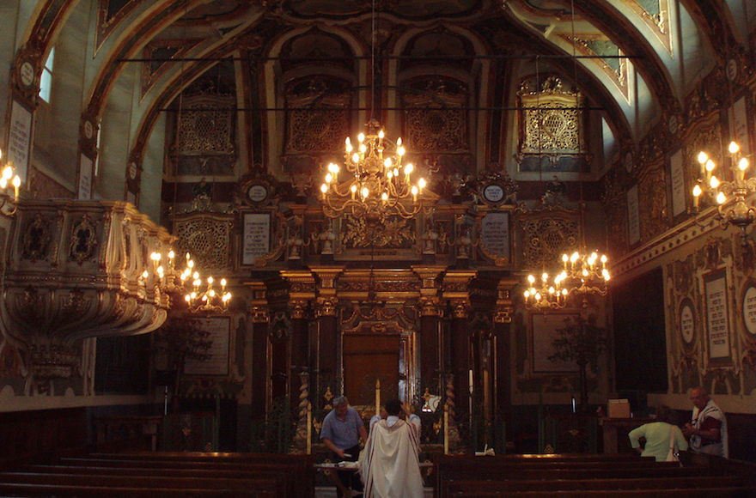
An inside view of the synagogue in Casale Monferrato, Italy, which dates to the 16th century. (Wikimedia Commons)

CASALE MONFERRATO, Italy (JTA) – It’s always Hanukkah in this picturesque town in northern Italy’s Piedmont region.
Jews have lived in Casale Monferrato for more than 500 years, with the community reaching its peak of 850 members at about the time Jews here were granted civil rights in 1848. The town still boasts one of Italy’s most ornate synagogues, a rococo gem that dates to the 16th century.
These days, only two Jewish families live in Casale. The synagogue, which is part of a larger museum complex, is now a major tourist attraction – and not only because of its opulent sanctuary with huge chandeliers, colorfully painted walls and lots of gilding. The former women’s section has been transformed into a Judaica and Jewish history museum. And the synagogue’s basement, formerly a matzah bakery, is now home to the Museum of Lights.
Hanukkah here is commemorated nonstop with a year-round exhibit featuring dozens of menorahs, or hanukkiyot, created by international contemporary artists. The collection has some 185 menorahs, according to Adriana Ottolenghi, whose husband, Giorgio, has been president of Casale’s Jewish community since the 1950s. There is no other museum in the world quite like it.
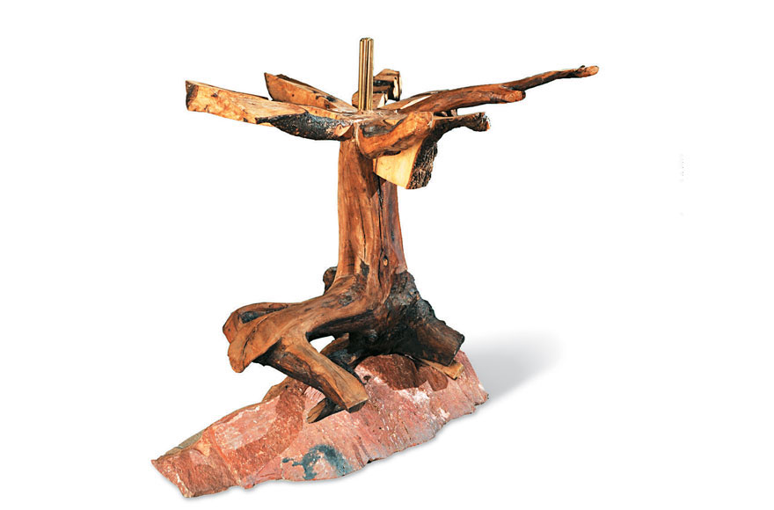
This is one of the nearly 200 menorahs at the Museum of Lights in Casale Monferrato (Foundation for Jewish Art, History, and Culture at Casale Monferrato and in Eastern Piedmont – Onlus)
“We receive more every year, and each year at Hanukkah there is a public ceremony, where we light menorahs and welcome the new pieces,” she said.
Only 30 to 40 can be displayed at a time in the vaulted underground chambers. The only time the collection was shown in its entirety was at Casale’s centuries-old castle, part of an event connected to the 2015 Milan Expo.
The Museum of Lights’ hanukkiyot come in an amazing variety of shapes, sizes, colors and media. Many resemble traditional menorahs: a straight line of candles or a candelabra with eight branches, with a ninth branch for the “shamash” candle used to kindle them. Some of the menorahs can be lighted and used on the holiday.
But other menorahs on display are more fanciful sculptural works created from the likes of metal, ceramic, plexiglass and wood.
“Artists were given a completely free rein to create a functional object or a purely evocative one,” curator Maria Luisa Caffarelli wrote in the collection’s catalog.
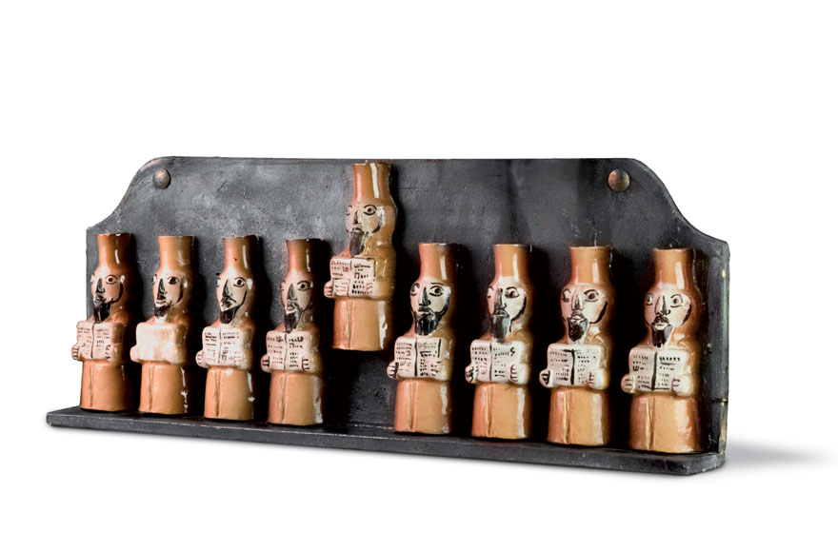
This menorah is part of the year-round display at the Museum of Lights. (Foundation for Jewish Art, History, and Culture at Casale Monferrato and in Eastern Piedmont – Onlus)

Each menorah is what designer Elio Carmi, who co-founded the collection in the mid-1990s with the non-Jewish artist Antonio Recalcati and other artist friends, describes as an “homage to the story of Hanukkah” and its message of the triumph of light over darkness.
They conceived the project as a way to highlight Jewish culture as a source of artistic inspiration, promote creativity based in Jewish tradition and underscore the vitality of Jews in contemporary society.
“The idea was born to show that Jews, though small in number, are determined,” said Carmi, who is the vice president of the Casale Jewish community, “and to use interpretations of the Hanukkah menorah to demonstrate, symbolically, the continuity of the community.”
At Hanukkah, Jews light menorahs for eight days to recall the defeat by the Maccabees of Syrian tyrants in the second century BCE. According to legend, when the Maccabees reclaimed the Temple, the eternal light miraculously burned for eight days rather than the expected one, symbolizing the survival of the Jewish people.
Each menorah in the museum is a personal interpretation of the Festival of Lights and its symbolism. The Italian artist Stefano Della Porta, for example, used ceramics and steel to create a menorah that appears to be made from giant burnt matches. American-born artist Robert Carroll created his menorah from olive wood, red Verona granite and brass. It has a sinuous, trunk-like base that supports eight branches that open out like a flower, each supporting a candle.
Carmi and his friends provided the first hanukkiyot for the project — Carmi’s was a silver-plated metal bar with small cups for the eight candles and the shamash — and then reached out to others for contributions.
Other artists — Jews and non-Jews, mainly from Italy but also from other countries — soon began making their own menorahs and presenting them to the growing collection. All of the works are donated, most of them by the artists themselves.
“It was like a chain of artists,” Carmi said. “And well-known artists began to be attracted.”
Among those is Arnaldo Pomodoro, one of Italy’s leading sculptors. His menorah, presented in 2013, is a horizontal metal girder that supports the nine candles and is decorated with abstract symbols.
“I tried to bring out a series of abstract, imaginary signs to create a story that would connect, on a general level, with the idea of thought, experience and memory; without, however, wanting to enter into the multi-faceted complexities of the symbology of the Jewish world,” Pomodoro describes in the catalog.
Ultimately, Carmi said, the Museum of Lights is about “Judaism, art and identity.”

Reprinted from the November 15, 2017 website of the JTA (Jewish Telegraphic Agency)
News Brief
Canada Issues First
Hanukkah Postage Stamp
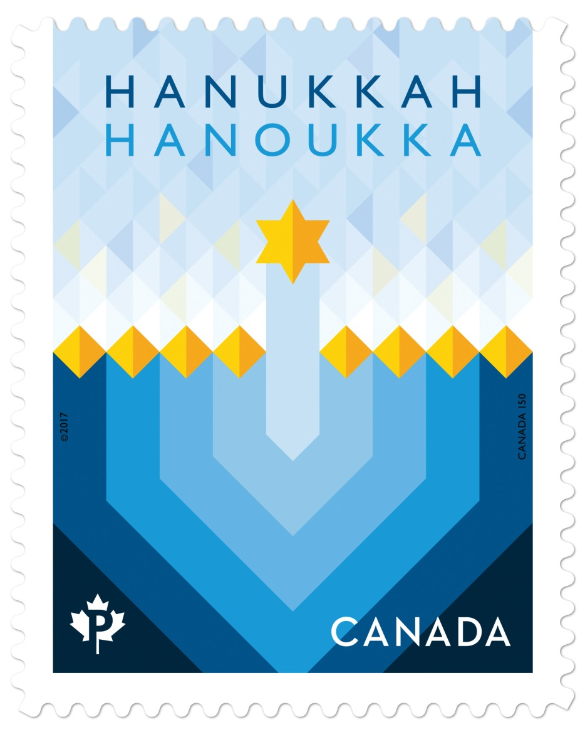
November 21, 2017
MONTREAL (JTA) — Canada issued its first Hanukkah stamp in its official mail carrier’s 150-year-history.
Described as part of an initiative to highlight the nation’s cultural diversity, the stamps from Canada Post feature two colorful geometric designs: of dreidels and the menorah. Each pattern also has an online explanation of their relevance to the holiday.
They are arriving three weeks before the first candle is lit.
“In offering the great products, Canada Post is enabling our community to share the beauty and inspiration of Hanukkah with all Canadians,” said Shimon Fogel, CEO of the Centre for Israel and Jewish Affairs.
Canada Post made an initial issue of 3 million Hanukkah stamps and has indicated that if trial-run sales go well, it will make more over the next few years and eventually add new designs.
As part of the diversity initiative, Canada Post also issued stamps for the Muslim festival of Eid and the Hindu holiday of Dawali. Since 1964 and until this year, it had issued only Christmas stamps.
(Editor’s Note: The first Canadian Hanukkah stamp was designed by Angela Brown Carter of Entro Communications, that has offices in Toronto and Calagary as well as in Switzerland.

What One Menorah
Lighting Can Do
By Chana Sara Einseiger

There was always something about lighting a menorah. Even when I was in foster homes as an adolescent, it was something I wanted to do. Maybe it was knowing that my ancestors did the exact same thing, or that millions of people all over the world were staring at the candles too. Or maybe it was just that candlelight is so warming when the ground outside is covered in snow. I’m not sure, but I certainly never expected that lighting a menorah would have any impact on my day-to-day existence.
Nearly three years ago I decided to drop Judaism entirely. I was fed up with the entire venture. The temple I attended was costly and uninviting, not at all what I had expected. There would be no community to raise my daughter with, no traditions to pass on to her. Needless I decided to drop Judaism entirelyto say, I was a little bitter about the whole thing.
But, of course, every year I lit a menorah. When my daughter was old enough to appreciate it, I decorated the house with Chanukah flags and garlands, window stickers and crafts. Maybe at some point in her life she too would enjoy the feeling of comfort and safety that I got from the flickering candles.
The temple with which I dropped membership proceedings still sent me a newsletter occasionally, and that year I saw that various synagogues were holding public menorah lightings around the county. A giant menorah! Perfect! I dressed up my little girl in a pretty blue dress and built her anticipation to see a menorah as tall as a tree.

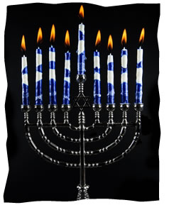

It turned out to be less dramatic than I had hoped—just a few people had gathered to see the lighting. Some homeless men were milling around. There was talk of free latkes and hot drinks in a nearby building afterwards, but as soon as the lighting was over I scooped up my daughter and made a dash for the car. My exoduswas interrupted the rabbi. He introduced himself and gave my daughter a little menorah necklace.
“Do you belong to a synagogue?” he asked.
“No,” I replied. The memory of the other temples I had been to, their high fees and constant focus on what my occupation is, rather than who my daughter and I are, made me suspicious of this rabbi. Does this one want twice the cost of my medical insurance for my daughter to play around his children?
The rabbi told me the address of his synagogue. I narrowed my eyes. ”And how much does it cost?”
His face lit up. “This is why I do this,” he said. He told me there were no membership fees. I was astounded.
So I went to the local Chabad Lubavitch. Yes, it was awkward. There was a definite language barrier, and I often had trouble following the service. But the people were friendly, and I didn’t have to sign There were no membership fees. I was astoundeda contract to be there. So I went back again, even though going to a Chabad synagogue if you weren’t raised in the world of Judaism is like diving before you learn to swim.
After some coaxing, the rabbi’s wife, Devorah, convinced me to sign up my daughter for Sunday Hebrew school. On the first day, they were having a shofar factory. The smell of power drills running into animal bones and shellac was awful, but my daughter loved it. She looked around wide-eyed at the other kids, made a friend, and was fascinated with the shofar she shellacked. I was sold.
On my way out, the rabbi said to me, “Look what one menorah lighting can do.” I smiled, but didn’t think much of it.
Time has gone by, and now I can’t forget the rabbi’s words. Yes, when I attend a service I still prefer to hide in the kids’ room, where I have some idea what I’m doing (mostly staring at the fish tank), and most of my agnostic-style views haven’t changed, but plenty has. My daughter finished a year in Hebrew school and is learning a new language. She is so proud of all her projects, and so happy with the friends she has made.
Because she enjoyed Hebrew school so much, I enrolled her in the Chabad preschool. She loves her teachers, and I’m glad that she’s in such capable hands. She has developed socially and gained a bit more confidence. After more coaxing from Devorah, she even attended summer camp. So much has changed in our routine, changes that will be there for years to come. She is making memories that she can treasure for life. That is what one menorah lighting can do.

Chana Sara lives in Whitehall, Pennsylvania, with her husband, daughter, and too many pets. She is the office manager at Chabad of the Lehigh Valley where she helps produce the Wellsprings Magazine which is published 5 times a year. What she enjoys most about working at a Chabad House is having the constant opportunity to learn something new.

Reprinted from the website of Chabad.Org

